The following people have been cleared by the Commission on Ministry to preach in churches of the Presbytery of Milwaukee when invited by the pastor with the concurrence of session or by the session in the absence of a pastor. The pastor or session seeking pulpit supply should make contact directly with the individual on the list.
Presbytery of Milwaukee’s recommended honorarium for a pulpit supply is $100 for one service and $125 for two services, in addition to the cost of travel at the current IRS rate.

At the end of this list, there are internet web addresses for information about mission speakers and missionaries who may be available for worship.
TED ANDERSON  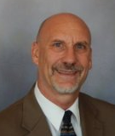 |  | 12410 W. Cleveland Ave, New Berlin, WI, 53151  262-312-4921  tvanderson@yahoo.com | Ted graduated from McCormick Theological Seminary. A member of Milwaukee Presbytery for over 20 years, he works primarily in community organizing and social services in the Milwaukee area. He is a grant writer, an interpreter, has worked lived and traveled in various countries. Ted is bilingual, Spanish-English, has two daughters and has served on various Presbytery committees such as Mission Partners and Nominating Committee.
JOHN BAUMANN |  | 238 Woodland Ct,  Lake Mills WI 53551  920-648-2943  jbbaumann@charter.net | Honorably retired, John served the Hartland, Kettle Moraine Church for many years. He was also active on many presbytery committees. John and his wife Beverly live in Lake Mills, often worshipping in the Madison area.
MARY CARLIN  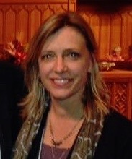 |  | 6155 N. Kent Ave  Whitefish Bay, WI 53217  414-964-5724  rev.marycarlin@gmail.com | Mary is a graduate of McCormick Theological Seminary. She is well known for her involvement in our presbytery, frequently called for pulpit supply, a member of several committees, currently serving on COM. Mary was a commissioner to GA in 2012, and chaired the search committee that brought Craig Howard here as our Executive Director of Strategic Partnerships. Mary’s great joy is her loving, supportive family that includes her husband Jude, a daughter and 2 sons. Mary thrives on the laughter and fellowship shared in her family.
MARTY COONS  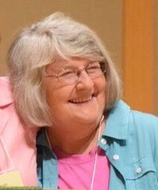 |  | 13405 Bobby Lane  Elm Grove, WI 53122  262-821-3648 (H)  262-573-0868 (C)  marty_coons@yahoo.com | Marty is a Trinity Lutheran Seminary graduate (M.Theology) and a McCormick Theological Seminary graduate (M.Divinity). She was ordained at Lisbon Pres. Church in 1998. After serving in Interim Ministry for 17 years with 12 area churches in 3 denominations, Marty retired Dec. 1, 2015. Marty and her husband Bob have 2 sons, 2 daughter-in-laws, Cosette their cat, and 5 grand cats!
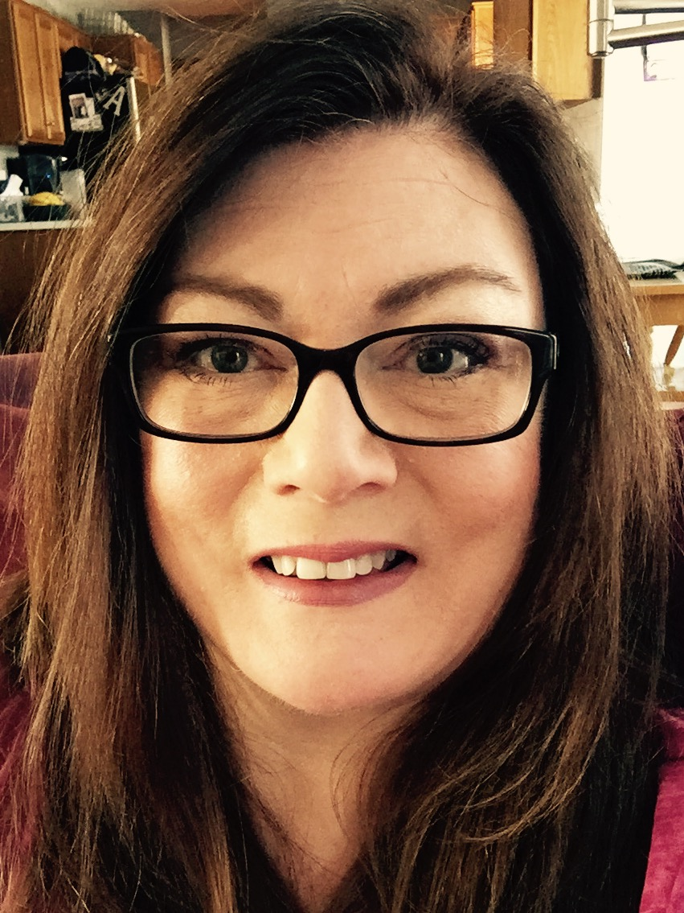  JULIE CRAIG |  | 545 Greenwood Court, Pewaukee WI 53072  (262) 695-0223  Julie@craig.net | Julie is a writer, speaker, preacher and graduate of San Francisco Theological Seminary. She and her spouse live in Pewaukee. She has served the denomination as a parish pastor, committee moderator, Council member, Synod Permanent Judiciary Commissioner, and for a brief, sweet time a Presbytery staff member whose office overlooked a vineyard in Napa, California. A failed knitter, reluctant dog walker, and capricious reader, she is fueled by strong coffee, deep laughter, and really cute shoes.
KATHRYN CRAVEN  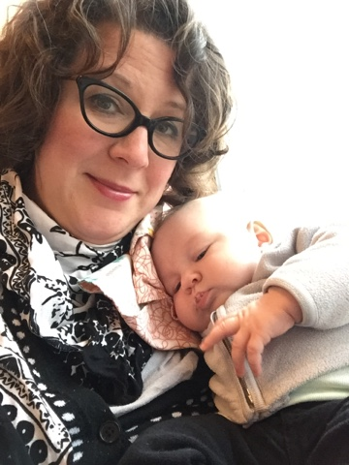 |  | 521 Monroe Street  Janesville, WI 53545  660-631-2788  katdianna@yahoo.com | Graduate of San Francisco Theo Seminary, Kathryn lives in Janesville with her beautiful baby, lovable husband, and entirely too many pets. She brings a fresh, creative spirit to worship, grounded in the reformed tradition. Kathryn spent a summer working and worshipping at the pilgrimage site of the Isle of Iona in Scotland. Kathryn is currently serving as part-time interim at North Lima Pres. Church
VI CROSS-DUKES  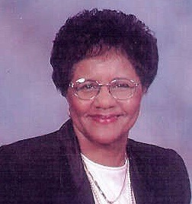 |  | 6952 N 44th Street Milwaukee WI 53223  414-228-1470  vcrossdukes@ameritech.net | On the path to becoming a minister, Vi discovered that to learn true faith – to learn about God – she had to learn about herself. She had to face up to where she’d come from, even as she’d spent her adulthood running from her childhood. Volina’s book, Getting Honest, is her account of the rich journey that made her see life in an entirely different way. Ms. Cross is now retired and living with her family in Milwaukee, Wisconsin.
BILL JOHNSTONE  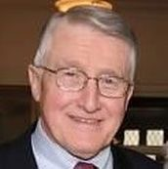 |  | 4049 N. Lake Dr.  Milwaukee, WI 53211  414-332-3498  wjohns4949@att.net | Honorably Retired, Bill was Head of Staff at Immanuel Presb. Church. He is an active member of presbytery, having served on many committees, including 2 terms as moderator.
BRUCE A. JONES |  | W9154 Bluewaters Pass  Cambridge, WI 53523  608-205-7428 (c)  608-423-2374 (h)  revjones96@gmail.com | Bruce served as pastor at 1st Janesville from 1999-2016. He and his wife, Krista, have 2 active boys, Jonathan and Alex. He is now working with the University of Wisconsin Extension in Youth Education for 4-H.
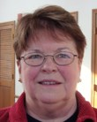  BARBARA JORDAN |  | 12530 N. Woodland Dr. Mequon WI 53092  262-242-2675  bjordan46@hotmail.com | After 30 years in corporate America, Rev. Jordan was ordained in 2002. She served as pastor of congregational care for nine years. Currently she serves as hospice chaplain at Zilber Family Hospice. “The opportunity to lead worship in many congregations across our Presbytery has brought me great joy and it is especially gratifying to meet so many folks seeking to deepen their faith in Jesus Christ.”
JERRY KRAMER  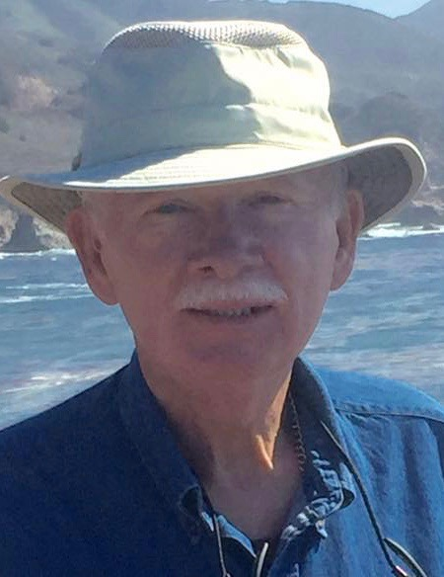 |  | N 7501 Kettle Moraine Dr. Whitewater, WI  262-473-0019 (H)  843-422-4060(C)  glkramer56@gmail.com | Jerry graduated from Calvin Theo. Seminary. He has a Master’s in Counseling and Psychological and a Doctor of Ministry from Bethel Theo. Seminary. Jerry has served 7 churches in MN, IA, WI, MI and SC. He did a Rim to Rim hike of the Grand Canyon, has kayaked the Apostle Islands, the Florida springs and the Everglades. In his retirement Jerry hikes the Ice Age Trail, refinishes furniture, reads, and listens to the Great Courses.
SARA MILES  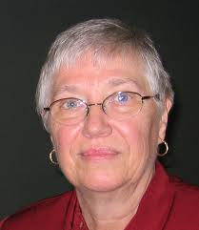 |  | 318 57th Street Unit #303  Kenosha WI 53140-4249  262-799-0752  Smiles303@wi,rr.com | Ruling Elder and member of Kenosha, First – Sara serves as a member of Council. She is a past moderator of Presbytery. She and her husband, John, served as missionaries in the Congo and both are highly involved in higher education. She is currently working on a book for teenagers, their parents & youth pastors on Science & Christian Faith.
CATHERINE NEAL  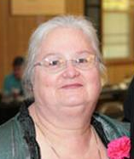 |  | 104 White Sand Lane,  Racine WI 53402  262-681-5386  servantcatherine@hotmail | Catherine completed a B.A. in Religion at Wittenberg University and during that time began the ordination inquiry process under the care of Miami Presbytery in Ohio. The Neal family moved to Racine and she began her theological studies at McCormick Seminary. She graduated in 2001, recipient of the Marshall L. Scott Labor/Urban Ministry Award. Catherine has completed four units of CPE at St. Luke's Hospital in Milwaukee. In June 2003, she accepted a call as Staff Chaplain with United Hospital System of Kenosha, WI.
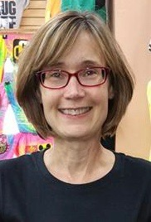  KATHY ROSEN | 1826 Dewitt Ct.  Waukesha, WI 53184  262-613-8524  Kathryn.rosen@froedtert.com |  | Kathy is a Ruling Elder at Delafield Pres. Church, where she is active in the music program. She has always felt a call to ministry, first in music ministry in her early teens. She has begun her training to become a Commissioned Ruling Elder, and sees this as an opportunity to serve the larger church. She has served on sessions, Commission on Ministry, and the Commission for Stony Hills. Kathy is an IT Manager at Froedtert Hospital.

DEB SWETS | W6815 N. Walworth Rd  Walworth, WI 53184  262-325-142  deb.j.swets@gmail.com | Deb is a graduate of Fuller Seminary and an Inquirer under care of our presbytery. Currently, she is a Ruling Elder at Rock Prairie. Pulpit supply is a great way for her to continue gaining experience preaching in different settings. Deb likes to sing, bake, paint and in other was express herself creatively. She has a passion for the Old Testament!
KELLY TALLEY | Grafton, WI  414-803-1353  dktalley@wi.rr.com | Kelly has recently retired from Alverno College where she worked in higher education for twelve years. She was the Director of the Assessment Center, Coordinator of the Diagnostic Digital Portfolio, and a member of the Council for Student Assessment. Graduate of McCormick Seminary, she has been active in our presbytery, particularly on CPM. In retirement, Kelly and Dee are updating an old farmhouse that they bought in Grafton.
CAROL WICKERSHAM  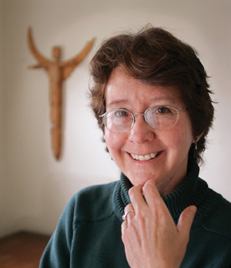 | 612 High Street,  Clinton, WI 53525  608-676-4583  clwickersham@charter.net | Carol has an M.Div. from Pacific School of Religion. Prior to joining the faculty at Beloit College, Carol served local congregations, at the World Council of Churches and as an adjunct faculty member in field education at San Francisco Theological Seminary. She is currently involved in attempts to secure humane treatment for US detainees as founder of No2Torture and as a board member of the National Religious Coalition Against Torture.

