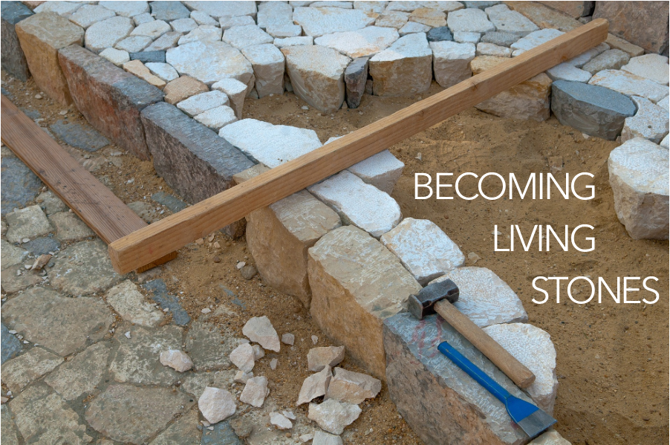

Come to him, a living stone, though rejected by mortals yet chosen and precious in God’s sight, and like living stones, let yourselves be built into a spiritual house, to be a holy priesthood, to offer spiritual sacrifices acceptable to God through Jesus Christ. For it stands in scripture:

“See, I am laying in Zion a stone,

a cornerstone chosen and precious;

and whoever believes in him will not be put to shame.”

1 Peter 2:4-6, NRSV

CHARGE & BENEDICTION

The world is full of Doubting Thomases. Know that this is a weighty burden they carry. Your call is to help share the load, not because you have all the answers, but because you are willing to struggle with them over the questions. Go in confidence that you are loved by God, covered by the grace of our Lord, Jesus Christ, and empowered by the Holy Spirit.

POSTLUDE

FotW: Feasting on the Word: Liturgies for Year B, Volume 1 - Worship Companion; Second Sunday of Easter

For the next six weeks, we will be moving through a series of readings that link us to the same emotions and questions that the early church had in the time after Jesus’ resurrection. In these next six weeks of worship, you are invited to find a stone you can hold, to be included as part of your worship.

WELCOME & INVITATION

Come to him, a living stone, though rejected by mortals yet chosen and precious in God’s sight.

**Like living stones, let us be built into a spiritual house; a holy priesthood.**

Doubt is natural part of faith. It helps us to deepen our relationship with God and encourages us to ask “hard” questions. What can weigh us down and become a barrier is the fear that we carry. We often become immobilized by our fear and are unable to perceive Christ’s movement in our life. While holding your stone, think about those times in your life you have let fear be your guide.

You will be invited to lay down your stone as a part of our Prayer of Confession.

PRELUDE

Our service of worship begins as we GATHER.

We sing our praises to God,

we are called to worship God,

we confess to God together,

we are reminded of God’s pardon of what we confess, and

we share signs of peace as we greet one another.

When we sing, we sing together, heeding Psalm 84, which encourages us all to:

Make a joyful noise to the Lord, all the earth;

break forth into joyous song and sing praises.

Our worship of God involves us all so there are many times when we speak together or when we respond to the leading of another. These times when we speak (and sing) together are noted by **bold text**.

CALL TO WORSHIP

Let us rejoice! The risen Christ is among us and greets us with the message of Peace!

**Like the disciples, we rejoice at the good news! Like the disciples, we also have our doubts.**

Jesus said, “Blessed are those who have not seen and yet have come to believe.”

**Open our hearts, O God, so that we too may have faith and not feel weighed down by our doubt!**

The risen Christ invites us to receive the Holy Spirit and to share the Good News.

**Let us be filled with the spirit and embrace the peace of Christ.**

**THINE IS THE GLORY** / Glory to God 238

CALL TO CONFESSION

We confess together as a community of faith because we acknowledge the reality of sin in the church, the world, and our personal lives, and so we ask God for forgiveness and help in amending our lives. And the proof of God’s amazing love is this: while we were sinners Christ died for us. Because we have faith in him, we dare to approach God with confidence, assured of a forgiveness already given through Christ. So, in faith and penitence, let us confess our sin before God and one another, first together and then in silence.

PRAYER OF CONFESSIONFotW

**You have shown yourself to us, O God, by Word and Spirit, with signs and wonders, in flesh and blood, yet we still struggle to live and believe the good news of Jesus Christ. Have mercy on us; forgive us. Enter into our lives and cast out our fear so that we may come to trust in you and have life in Jesus’ name. Amen.**

Find a place and lay down your stone, your fears, into God’s keeping now.

ASSURANCE OF FORGIVENESS

Friends, hear the good news! Who is in a position to condemn? Only Christ, and Christ died for us, Christ rose for us, Christ reigns in power for us, Christ prays for us. Anyone who is in Christ is a new creation. The old life has gone; a new life has begun. Know that we are forgiven and be at peace. **Amen.**

As the service of worship of God comes to a close, we acknowledge that God SENDS us out into the world to be bearers of the good news of God.

We sing a song affirming the calls God has placed on our hearts,

we receive a charge reminding us of God’s call, and

we are bid into the work of God with a blessing.

God of tenderness, we pray your presence with healthcare workers who have seen and who have experienced painful and haunting things in the midst of their struggles to be restorers of health. Comfort them in their grief as you comfort all who have been touched by death, which comes in many forms. Give us the strength to be those upon whom they can lean, to be those who can listen.

God of green things, around us the world still shows signs of life as it has done spring after spring for millennia. Open our eyes that we might receive the miracle of small, new leaves, the miracle of the flight of birds and butterflies, the miracle of kindnesses in small gestures. May we see the evidences of goodness and, even more so, may we be the evidence of goodness, we pray. We ask all of these things through Christ, who taught us to pray, saying:

LORD’S PRAYER

OFFERING

Thomas found himself weighed down by doubt. He insisted on proof before he could believe. Sometimes we experience the same doubt when given the opportunity to make our offering. We question what expenses might come our way and whether we can afford to be generous. We ask how the money will be used and whether it will make a difference. You are invited to set aside the weight of those doubts and experience the joy of trusting in the goodness of the Lord to sustain us. Please consider giving online or by check this week.

ANNOUNCEMENTS

**WE WALK BY FAITH AND NOT BY SIGHT** / Glory to God 817

We continue our worship as the Word is PROCLAIMED.

We pray that the Holy Spirit helps us receive the Word spoken,

we hear Scripture(s) in song and word,

we listen to a reflection on the Scripture(s), and

we begin our own reflection during a period of quiet.

We RESPOND to the Word as:

We affirm our faith in song,

we offer our prayers to God, and

we commit through offering to God’s work in the world.

On the first Sunday of each month, we celebrate the Lord’s Supper.

Through the seasons of the church, we also baptize children of God, ordain and install officers, and respond to God’s call upon us through other expressions.

with friends.

Let’s pray to Jesus right now: dear Jesus, we have a lot of questions. Thank you for listening to our questions and helping us to understand. Amen!

PRAYER FOR ILLUMINATION FotW

God of all who doubt and believe, by the gift of your Spirit enable us to hear with our ears, to see with our eyes, and to touch with our hands your Word of life - Jesus Christ - our Lord and our God. Amen.

SCRIPTURE / John 20:19-31

MESSAGE

**THAT EASTER DAY WITH JOY WAS BRIGHT** / Glory to God 254

PRAYERS OF THE PEOPLE

God of mercy, we are afraid. We are afraid for our loved ones, for our neighbors and our communities, our nation and all nations, for ourselves. Help us to honor the feeling of fear without becoming paralyzed by it, without becoming hardened, without turning inward because of it. In life and in death we belong to you, made certain by Jesus’ resurrection, so fresh in our minds. Send your Spirit to fill us with courage that is bigger than fear, that we might be holders and carriers and sharers of hope in you.

CHILDREN’S MESSAGE

*Supplies: large rocks, basket, or bag*

*Leader puts heavy stones into a basket or bag, after asking question or making a statement.*

When we read the Bible today we hear the story about one of Jesus’ friends named Thomas. Thomas couldn’t believe that Jesus had come back to life, even though their other friends told Thomas they had actually seen Jesus. Thomas had a lot of questions. He couldn’t be happy like his friends who had seen Jesus alive because Thomas didn’t know if it was true.

Sometimes we can have a lot of questions, especially questions about God.

How come I can’t see God? *(stone placed in bag)*

How could Jesus come back to life? *(stone place in bag)*

If God can do anything, why are people poor or hungry? *(stone placed in bag)*

Why do people get sick or die? *(stone placed in bag)*

These are lots of heavy questions. Another thing can feel heavy are our emotions.

I feel sad. *(stone placed in bag)*

I feel mad. *(stone placed in bag)*

You can imagine this bag is pretty heavy now. When we have too many unanswered questions or lots of unhappy feelings, it can be hard to play or go to school or be with friends. We need help. Jesus is someone we can ask for help. *[slowly remove stones from bag].*

When we pray, we can ask Jesus to help us understand and to answer our questions; we can ask Jesus to help us feel better. Then it’s easier to play or go to school or be