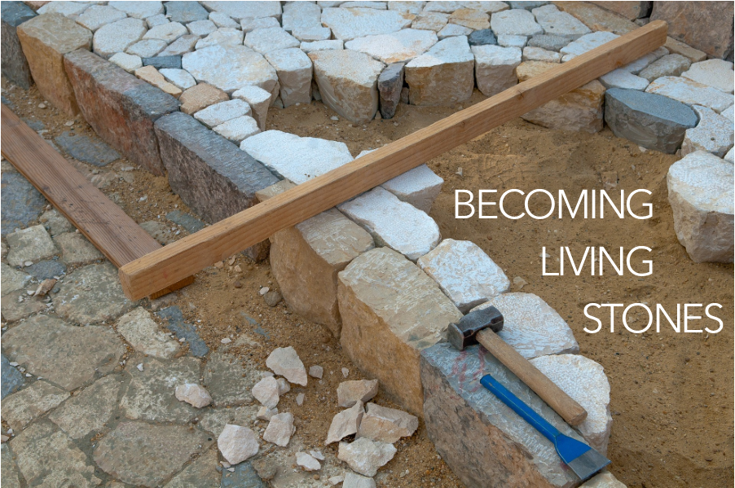

As you come to him, the living Stone - rejected by humans but chosen by God and precious to [God] - you also, like living stones, are being built into a spiritual house to be a holy priesthood, offering spiritual sacrifices acceptable to God through Jesus Christ. For in Scripture it says:

“See, I lay a stone in Zion,

a chosen and precious cornerstone,

and the one who trusts in him

will never be put to shame.”

1 Peter 2:4-6, NIV

open in wonder, may you encounter the Risen Christ in your midst.

POSTLUDE

FotW: Feasting on the Word: Liturgies for Year B, Volume 1 - Worship Companion; Third Sunday of Easter

Our service of worship begins as we GATHER.

We sing our praises to God,

we are called to worship God,

we confess to God together,

we are reminded of God’s pardon of what we confess, and

we share signs of peace as we greet one another.

When we sing, we sing together, heeding Psalm 84, which encourages us all to:

Make a joyful noise to the Lord, all the earth;

break forth into joyous song and sing praises.

Our worship of God involves us all so there are many times when we speak together or when we respond to the leading of another. These times when we speak (and sing) together are noted by **bold text**.

For the weeks between now and the week before Pentecost, we are moving through a series of readings that link us to the same emotions and questions that the early church had in the time after Jesus’ resurrection. Last week, we learned about the weight of Thomas’ fear (and our own) and about what it means to follow a risen Christ. This week, we will walk the road to Emmaus, aware of the rocks that make us stumble in our faith journey. In the following five weeks of worship, you are invited to find a stone you can hold, to be included as part of your worship.

WELCOME & INVITATION

As you come to him, the living stone - rejected by humans but chosen by God and precious to God…

**We, like living stones, are being built into a spiritual house to be a holy priesthood.**

As you reflect upon your journey of faith thus far and perhaps the path that is before you, think about the obstacles, rocky or uneven terrain that have caused you to stumble - either as an individual or as a community of faith. Consider what has caused you and/or your community to stumble as you walk along your journey with the Risen Christ.

You will be invited to lay down your stone as part of our Prayer of Confession.

PRELUDE

CALL TO WORSHIP

Friends, the Risen Lord is among us and walks with us on our journey.

**Open our eyes that we might recognize him and follow him.**

God may come to us, unrecognized, as a stranger as we travel our own Emmaus roads.

**May the words of the Risen Christ burn in our hearts as we continue on our journey.**

Open your eyes this day to see the goodness of the Lord.

**Open our hearts, gracious God, to receive your blessings.**

**IN CHRIST THERE IS NO EAST OR WEST** / Glory to God 317

CALL TO CONFESSION

We confess together as a community of faith because we acknowledge the reality of sin in the church, the world, and our personal lives, and so we ask God for forgiveness and help in amending our lives. And the proof of God’s amazing love is this: while we were sinners Christ died for us. Because we have faith in him, we dare to approach God with confidence, assured of a forgiveness already given through Christ. So, in faith and penitence, let us confess our sin before God and one another, first together and then in silence.

PRAYER OF CONFESSIONFotW

**Good and gracious God, we are creatures of dust, ignorant of your revelation, misunderstanding of your life, death, and resurrection among us, needing forgiveness. We repent of our failure to give as you have given to us. We beg your mercy for our fallen world. We seek your Word, that we may live with the faith of Jesus. Be our solace in this life and always. We ask this as your own children, holy and incomplete. Forgive us and lead us. Amen.**

Find a place and lay down your stone, your stumbling blocks, into God’s keeping now.

ASSURANCE OF FORGIVENESS

Friends, hear the good news! Who is in a position to condemn? Only Christ, and Christ died for us, Christ rose for us, Christ reigns in power for us, Christ prays for us. Anyone who is in Christ is a new creation. The old life has gone; a new life has begun. Know that we are forgiven and be at peace. **Amen.**

As the service of worship of God comes to a close, we acknowledge that God SENDS us out into the world to be bearers of the good news of God.

We sing a song affirming the calls God has placed on our hearts,

we receive a charge reminding us of God’s call, and

we are bid into the work of God with a blessing.

God of our hearts, you made us to be healthiest when in community and we have found ourselves unthinkably separated. Strengthen us for these times apart. Guide us into new ways of connection and open our hearts that we might welcome them even as we sincerely grieve the ways that were.

God who was and is and will be, be with us as we process what has been, what is, and what is to come, for it all seems too much. Send your Spirit of grace upon us that we might find grace for ourselves and for others in these overwhelming times, we pray. We ask all of these things through Christ, who taught us to pray, saying:

LORD’S PRAYER

OFFERING

Sometimes the rocks on the road of Christian discipleship cause us to stumble. We trip over bad habits and stub our toes on practices that seem perfectly sensible from the world’s perspective, but that keep us from recognizing our Lord who walks beside us. Spiritual practices like prayer and reading the Bible and charitable giving help us to avoid the rocks in the road. Your offering will allow us all to keep our eyes fixed on Jesus that we might walk with him without stumbling. Please consider giving online or by check this week.

ANNOUNCEMENTS

**CHRIST IS RISEN! SHOUT HOSANNA!** / Glory to God 248

CHARGE & BENEDICTION

The road to Emmaus awaits us all. You will not walk this journey alone for we take our community with us wherever we are. May the road before you be smooth, not rocky; may it be level, not steep; may it provide adventure, but not danger. And, with eyes

We continue our worship as the Word is PROCLAIMED.

We pray that the Holy Spirit helps us receive the Word spoken,

we hear Scripture(s) in song and word,

we listen to a reflection on the Scripture(s), and

we begin our own reflection during a period of quiet.

We RESPOND to the Word as:

We affirm our faith in song,

we offer our prayers to God, and

we commit through offering to God’s work in the world.

On the first Sunday of each month, we celebrate the Lord’s Supper.

Through the seasons of the church, we also baptize children of God, ordain and install officers, and respond to God’s call upon us through other expressions.

Let’s pray: Jesus, we are glad that you are alive. Help us to see you or things that you have made like our beautiful world, our friends, and our families. Remind us to look for you. Amen!

PRAYER FOR ILLUMINATION FotW

Holy God, by your Spirit reveal your radical, surprising love; come to us through your holy word, and let us hear what you are saying. **Amen.**

SCRIPTURE / Luke 24:13-35

MESSAGE

**DAY OF ARISING** / Glory to God 252

PRAYERS OF THE PEOPLE

God who led the Israelites by day and by night, in cloud and in fire, we find ourselves stumbling like they did. We are afraid of change so we point fingers, we complain that things aren’t like they used to be, we dig our heels in, we promise we are going back from where we came. Help us to remember that even though the circumstances of the Israelites changed, you did not. You remained in relationship with them as you do with us, into every new place and time. Open our eyes and our hearts that we might follow your lead for you have already been where we are going and you do not leave us to walk alone.

CHILDREN’S MESSAGE

*Supplies: small stones*

*Leader lays out a path with stones on it.*

In the Bible today, we hear about two people who were walking along a road, and Jesus joined them. They didn’t recognize him, even though they knew Jesus. The three of them kept walking and talking, but the people didn’t know that it was Jesus. They thought Jesus was dead. Only later when they stopped and ate dinner with Jesus did they recognize him.

The people couldn’t see Jesus, even though he was right there with them. It was like they had their eyes covered.

Imagine if I asked you to walk this curvy path with your eyes closed. Would you be able to see where you were going? What did you think you would feel under your feet? Would that make walking easy or hard?

What if your eyes were opened? Would you be able to miss the rocks? Would it be easier?

When we walk, it’s better to not have our eyes closed or covered, so we can tell where we’re going and so we don’t trip on rocks. The two people who were walking with Jesus didn’t have their eyes covered, but they still couldn’t see Jesus because they didn't look for him.

When our eyes are open, we can look for Jesus or things that remind us of Jesus. When we see a friend whom we really like, we can remember how much Jesus loves us. When we see a beautiful tree or a sunset or a friendly dog, we can thank God for making our world.