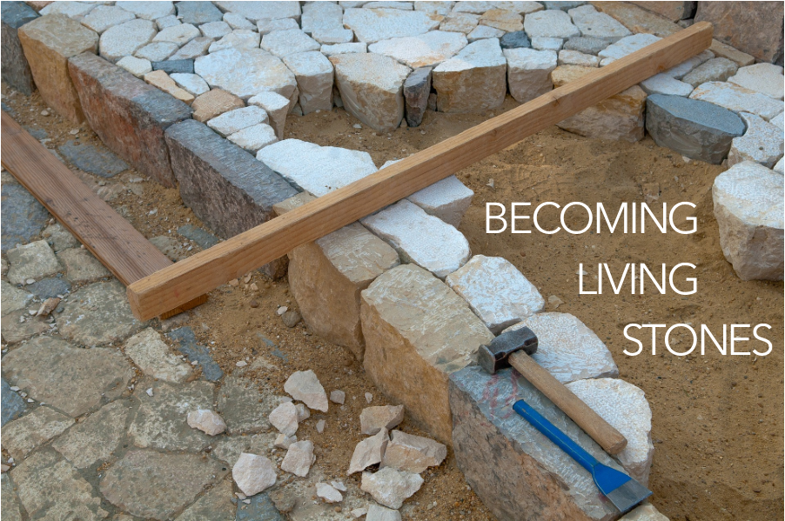

Now you are coming to him as to a living stone. Even though this stone was rejected by humans, from God’s perspective it is chosen, valuable. You yourselves are being built like living stones into a spiritual temple. You are being made into a holy priesthood to offer up spiritual sacrifices that are acceptable to God through Jesus Christ. Thus it is written in scripture, Look! I am laying a cornerstone in Zion, chosen, valuable. The person who believes in him will never be shamed.

1 Peter 2:4-6, CEB

As part of our worship series today, we experience a shift. The symbolic stones that have weighed us down, caused us to stumble, and offered false security are used this week to build God’s house, a place with many rooms. In the following three weeks of worship, you are invited to find a stone you can hold, to be included as part of your worship.

WELCOME & INVITATION

Now you are coming to him as to a living stone. Even though this stone was rejected by humans, from God’s perspective it is chosen, valuable.

**We ourselves are being built like living stones into a spiritual temple. We are being made into a holy priesthood to offer up spiritual sacrifices that are acceptable to God through Jesus Christ.**

Jesus reminds us that in God’s house there are many rooms, there is much space, and that God’s kingdom includes and welcomes all. We are called out into the world to continue building and expanding the reign of God which has no limits. Holding your stone, think about how you as an individual or as a community of faith can build upon God’s expanding reign.

You will be invited to lay down your stone during the second hymn.

PRELUDE

CALL TO WORSHIP

Jesus said, I go and prepare a place for you, and I will come again.

**We gather in this place to know your presence and your love.**

Jesus said, I am the Way, and the Truth, and the Life. If you know me, you know God.

**We pray to know you more deeply, that we may know God more intimately.**

Jesus said, in God’s house there are many rooms, there are many places where God dwells on earth.

**We search to know God out in the world, to engage more deeply and love more thoroughly.**

Let us begin by, together, worshipping God in this place and at this time.

**SING PRAISE TO GOD WHO REIGNS ABOVE** / Glory to God 645

Our service of worship begins as we GATHER.

We sing our praises to God,

we are called to worship God,

we confess to God together,

we are reminded of God’s pardon of what we confess, and

we share signs of peace as we greet one another.

When we sing, we sing together, heeding Psalm 84, which encourages us all to:

Make a joyful noise to the Lord, all the earth;

break forth into joyous song and sing praises.

Our worship of God involves us all so there are many times when we speak together or when we respond to the leading of another. These times when we speak (and sing) together are noted by **bold text**.

CALL TO CONFESSION

We confess together as a community of faith because we acknowledge the reality of sin in the church, the world, and our personal lives, and so we ask God for forgiveness and help in amending our lives. And the proof of God’s amazing love is this: while we were sinners Christ died for us. Because we have faith in him, we dare to approach God with confidence, assured of a forgiveness already given through Christ. So, in faith and penitence, let us confess our sin before God and one another, first together and then in silence.

**PRAYER OF CONFESSION** FotW

**God of mercy, we confess that we have not borne the fruit of the Spirit. We have not loved others as you have loved us. We have denied the promises of baptism and cut ourselves off from you. Forgive us, restore us, that we may abide in your love and live out your mercy, for the sake of Jesus Christ, in whose name we pray. Amen.**

ASSURANCE OF FORGIVENESS

Friends, hear the good news! Who is in a position to condemn? Only Christ, and Christ died for us, Christ rose for us, Christ reigns in power for us, Christ prays for us. Anyone who is in Christ is a new creation. The old life has gone; a new life has begun. Know that we are forgiven and be at peace. **Amen.**

We continue our worship as the Word is PROCLAIMED.

We pray that the Holy Spirit helps us receive the Word spoken,

we hear Scripture(s) in song and word,

we listen to a reflection on the Scripture(s), and

we begin our own reflection during a period of quiet.

CHILDREN’S MESSAGE

*Supplies: many small stones*

*Leader creates an outline of rooms in a house with small stones.*

Let’s pretend that each of these spaces is a room in God’s house. Who gets to live in God’s house? Would everyone in your family get to live there? How about everyone in this church? How about everyone at your school?

How many rooms do we need to make? Do we need more rocks?

Who else is invited to God’s house? Should we make more rooms over here?

Sometimes we look around at our church building, and we think this is where God lives. We learn in the Bible that God has a house with many rooms, enough rooms for all of us, for everyone.

Let’s pray: Thank you God for building a big house in heaven with many rooms, so that everyone has a place to be with you. We are glad you are here with us. We are glad you are at church. We are glad you are with other people at their homes and churches, too. Amen!

PRAYER FOR ILLUMINATION FotW

Come, Holy Spirit, that through your word we may be guided into the love of God for all the world. **Amen.**

SCRIPTURE / John 14:1-4

We RESPOND to the Word as:

We affirm our faith in song,

we offer our prayers to God, and

we commit through offering to God’s work in the world.

On the first Sunday of each month, we celebrate the Lord’s Supper.

Through the seasons of the church, we also baptize children of God, ordain and install officers, and respond to God’s call upon us through other expressions.

During the hymn find a place and lay down your stone, the way you can share in expanding God’s reign, to share with God, into God’s keeping now.

**FROM ALL THAT DWELL BELOW THE SKIES** / Glory to God 327

PRAYERS OF THE PEOPLE

God, we have gotten comfortable with our own four walls, whether they be the walls of our homes or the walls of our churches. It’s possible we’ve even become accustomed to our isolation, finding new routines which placate us. Stir us from our cocoons, from our fortresses, from our hiding places to remember that there are others outside the walls. There are others who have been impacted disproportionately because of their income or lack thereof, because of the color of their skin, because of systems that left them with no passed-on wealth, no safety net, poorer health before the virus even began. Open our eyes to see these siblings of ours, to see clearly the disadvantages that were set up and reinforced and bolstered generations ago, which must be broken down and discarded in place of systems which bring equity and health and enough for all. Stir us to strive for better than the way it was before we were safer-at-home, for the sake of all your children.

God of beauty, in these recent weeks we have relied on the beauty of the arts to give us relief, in storytelling and visual arts and television and movies and music and baking and cooking and dance. Help us go beyond appreciating them for the solace, and even happiness, they brought and move us to demand equity and health and enough for all who made these forms of beauty possible, for our world is surely richest when there are arts. And we don’t want to forget that. Help us to not forget that, we pray.

God of this world, show us the ways we can work for the good of all your people even when we are contained within our walls. Spur us to continue serving in your name even while we await the time to be freely outside walls and doing your work from there. We ask all of these things through Christ, who taught us to pray, saying:

LORD’S PRAYER

OFFERING

When we receive your offering, we often talk about how it will be used for the sustaining of the church - our ministries, our worship, and the building. The house that God builds, however, is not limited to this building. With thanksgiving that God is preparing rooms to receive all nations, we make gifts with joyous hearts. Please

MESSAGE

As the service of worship of God comes to a close, we acknowledge that God SENDS us out into the world to be bearers of the good news of God.

We sing a song affirming the calls God has placed on our hearts,

we receive a charge reminding us of God’s call, and

we are bid into the work of God with a blessing.

consider giving online or by check this week.

ANNOUNCEMENTS

**O CHRIST, THE GREAT FOUNDATION** / Glory to God 361

CHARGE & BENEDICTION

We have joined with Christians around the world this day to worship God: in sanctuaries, in houses, under shade trees and thatched roofs, and in grand cathedrals. God’s house has many rooms, and it is still not full. Go now into the world, ready to find God in the most unlikely places. Go now with confidence that there is a room - a place of love - reserved especially for you.

POSTLUDE

FotW: Feasting on the Word: Liturgies for Year B, Volume 1 - Worship Companion; Fifth Sunday of Easter