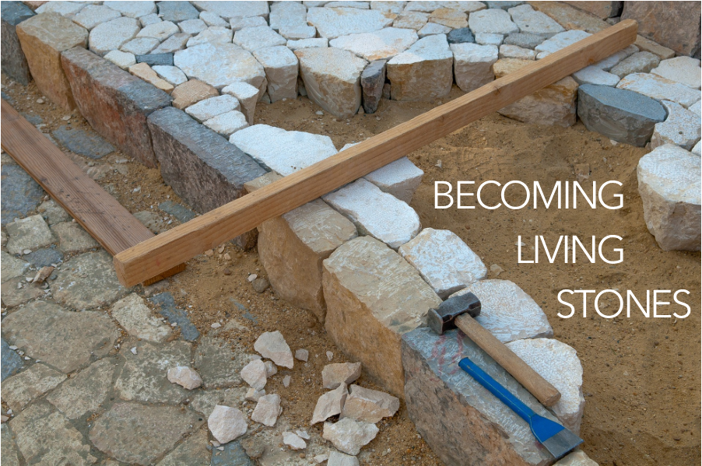

You are coming to Christ, who is the living cornerstone of God’s temple. He was rejected by people, but he was chosen by God for great honor.

And you are living stones that God is building into his spiritual temple. What’s more, you are his holy priests. Through the mediation of Jesus Christ, you offer spiritual sacrifices that please God. As the Scriptures say,

“I am placing a cornerstone in Jerusalem,

chosen for great honor,

and anyone who trusts in him

will never be disgraced.”

1 Peter 2:4-6, NLT

We are coming close to the end of our worship series. Today, we move from the stones that build God’s house to a recognition that God is not contained in any house. These physical walls have been marked and limited in time by God, but God’s church knows no such limits.

WELCOME & INVITATION

You are coming to Christ, who is the living cornerstone of God’s temple. He was rejected by people, but he was chosen by God for great honor.

**And we are living stones that God is building into a spiritual temple. What’s more, we are God’s holy priests. Through the mediation of Jesus Christ, we offer spiritual sacrifices that please God.**

If you’ve been with us the last four weeks, you may have noticed that there are no stones for our beginning time of reflection! God is everywhere and can not be contained! God is limitless and is not confined in our church walls or built into a shrine or shaped by our human minds. God dwells in and among all peoples and places and lovingly embraces all of creation!

PRELUDE

CALL TO WORSHIP / Finding God

**We worship the God who inhabits our world**

**and indwells our lives.**

**We need not look up to find God,**

**we need only to look around:**

**within ourselves,**

**beyond ourselves,**

**into the eyes of another.**

**We need not listen for a distant thunder to find God,**

**we need only listen to the music of life,**

**the words of children,**

**the questions of the curious,**

**the rhythm of a heartbeat.**

**We worship the God who inhabits our world**

**and who indwells our lives.**

Our service of worship begins as we GATHER.

We sing our praises to God,

we are called to worship God,

we confess to God together,

we are reminded of God’s pardon of what we confess, and

we share signs of peace as we greet one another.

When we sing, we sing together, heeding Psalm 84, which encourages us all to:

Make a joyful noise to the Lord, all the earth;

break forth into joyous song and sing praises.

Our worship of God involves us all so there are many times when we speak together or when we respond to the leading of another. These times when we speak (and sing) together are noted by **bold text**.

**GOD, YOU SPIN THE WHIRLING PLANETS** / Glory to God 23

CALL TO CONFESSION

We confess together as a community of faith because we acknowledge the reality of sin in the church, the world, and our personal lives, and so we ask God for forgiveness and help in amending our lives. And the proof of God’s amazing love is this: while we were sinners Christ died for us. Because we have faith in him, we dare to approach God with confidence, assured of a forgiveness already given through Christ. So, in faith and penitence, let us confess our sin before God and one another, first together and then in silence.

**PRAYER OF CONFESSION** FotW

**Loving God, we have not loved you or each other with our whole hearts. Forgive us, we pray, and lead us toward wholeness, that we may be filled with your joy. In Jesus’ name we pray. Amen.**

ASSURANCE OF FORGIVENESS

Friends, hear the good news! Who is in a position to condemn? Only Christ, and Christ died for us, Christ rose for us, Christ reigns in power for us, Christ prays for us. Anyone who is in Christ is a new creation. The old life has gone; a new life has begun. Know that we are forgiven and be at peace. **Amen.**

We continue our worship as the Word is PROCLAIMED.

We pray that the Holy Spirit helps us receive the Word spoken,

we hear Scripture(s) in song and word,

we listen to a reflection on the Scripture(s), and

we begin our own reflection during a period of quiet.

CHILDREN’S MESSAGE

*Supplies: large flat stones that can be stacked, or small stones gathered into a pile*

In the Bible, we hear about a man named Paul, who went to a city called Athens. The city is in a country called Greece. Maybe one day you’ll have a chance to visit it.

Paul went there to tell people about Jesus because they didn’t know much about him. The people in the city thought there were a lot of different gods, and they would make little houses out of stones, in the hope that the gods would live in them. Paul helped the people in Athens to understand there is only one God - God who created the whole world - and that God doesn’t need houses that people built. He told them that God gives us our breath and our life. We can’t put God in a pile of rocks.

When we leave the church building, we lock the door. Is God locked inside when we leave? No! We can’t keep God inside *these* rocks either. God is outside with everything that God created and everything that has life and breath.

Let’s pray: God, thank you for giving us breath and making us alive. Thank you for the world. We are so glad that you are inside the church and outside the church. Amen!

PRAYER FOR ILLUMINATION FotW

Pour out your Holy Spirit upon us, O God, in the reading of your Word, that we would hear what you have to say to us today. May your Holy Spirit be poured out upon us; through Jesus Christ. **Amen.**

SCRIPTURE / Acts 17:22-31

MESSAGE

We RESPOND to the Word as:

We affirm our faith in song,

we offer our prayers to God, and

we commit through offering to God’s work in the world.

On the first Sunday of each month, we celebrate the Lord’s Supper.

Through the seasons of the church, we also baptize children of God, ordain and install officers, and respond to God’s call upon us through other expressions.

**GOD OF OUR LIFE** / Glory to God 686

PRAYERS OF THE PEOPLE

God beyond our comprehension, we have put you in our neat little containers because we find you easiest to understand that way, not because you are that way. We have made you tiny, fitting neatly in a book, or on a cross around our necks or tattooed on our arms, or even into a sanctuary. Like the blossoms which are bursting forth, propel our understandings out of those small, confining places that we might find a glimpse of your expansiveness, your expansive care, your expansive love in its full glory. We pray for that same expansiveness to burst from us, unlocking our tight ways and providing us a freedom which comes from the abundance you offer. Open our hands that we might risk offering abundance from our material goods; open our hearts that we might risk offering abundance in love; open our mouths that we might risk offering abundance of grace. In so doing, might we also know abundant life, we pray.

God beyond our walls, what mighty things you have done in this world, across generations, and through your people. We give you thanks for the myriad good things that have happened in trying times. We give you thanks for the people who have been part of bringing good and we thank you for the ways your Spirit has nudged us to be bringers of good. When we fatigue and grow weary, send us strength for the work to be done, we pray. When we feel overwhelmed, send us partners in the creation of kindness. When we doubt, send us affirmations that the good we do matters. We ask all of these things through Christ, who taught us to pray, saying:

LORD’S PRAYER

OFFERING

God has marked the work of the church by time and boundaries. We will not be here forever, nor does God intend that. We can, however, be part of God’s mission in the world right now. Through your gifts, we can actively join in what God is doing in our community and around the world. Please consider giving online or by check this week.

ANNOUNCEMENTS

As the service of worship of God comes to a close, we acknowledge that God SENDS us out into the world to be bearers of the good news of God.

We sing a song affirming the calls God has placed on our hearts,

we receive a charge reminding us of God’s call, and

we are bid into the work of God with a blessing.

**THE CHURCH OF CHRIST CANNOT BE BOUND** / Glory to God 766

CHARGE & BENEDICTION

The walls of the church are solid; they have withstood storms from without and remodeling from within. But, these walls will not stand forever, for God has marked our time and boundaries. For the time allotted to us then, let us not be the church behind the walls, but the church beyond the walls. May the Triune God - three in one - bless you and keep you from this day forward.

POSTLUDE

Finding God: posted on the Presbyterian Church USA website; https://www.pcusa.org/site_media/media/uploads/peacemaking/pdf/mlk-resources.pdf

FotW: Feasting on the Word: Liturgies for Year B, Volume 1 - Worship Companion; Sixth Sunday of Easter