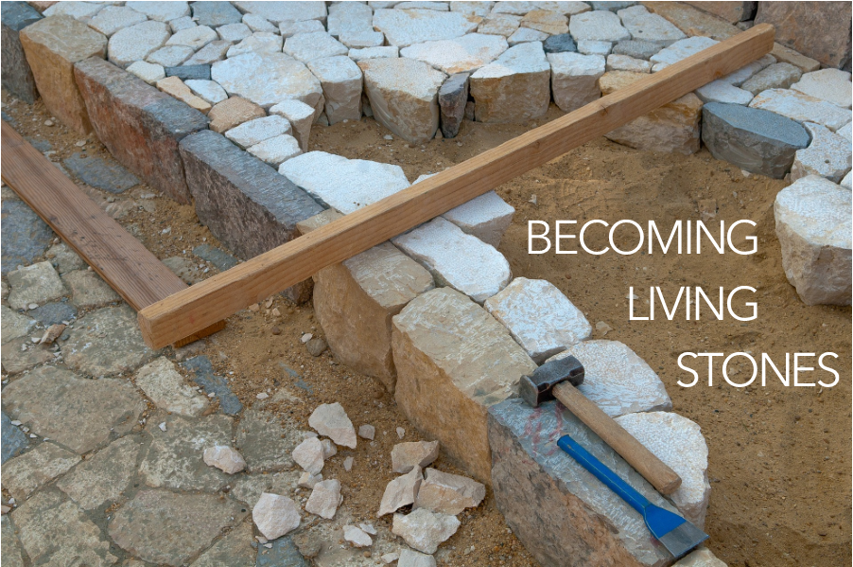

As you come to him, a living stone rejected by [humans] but in the sight of God chosen and precious, you yourselves like living stones are being built up as a spiritual house, to be a holy priesthood, to offer spiritual sacrifices acceptable to God through Jesus Christ. For it stands in Scripture:

“Behold, I am laying in Zion a stone,

a cornerstone chosen and precious,

and whoever believes in him will not be put to shame.”

1 Peter 2:4-6, ESV

You are invited to find a stone you can hold, to be included as part of your worship. You will be invited to lay down your stone as a response to today’s sermon/message.

WELCOME & INVITATION

As you come to him, a living stone rejected by humans but in the sight of God chosen and precious…

**We, like living stones, are being built up as a spiritual house, to be a holy priesthood, to offer spiritual sacrifices acceptable to God.**

PRELUDE

CALL TO WORSHIP

We gather together in the presence of our Shepherd God.

**The One who calls us each by name, who restores our souls, and leads us in the way of righteousness.**

God’s goodness and love never stop pursuing us.

**This is the God we have come to worship!**

**THE KING OF LOVE MY SHEPHERD IS** / Glory to God 802

CALL TO CONFESSION

PRAYER OF CONFESSION FotW

**Lord, have mercy on us. We talk about love, but our actions betray us. We talk about love, but we neglect the poor. We talk about love, but we fail to love one another. Lord, have mercy on us. Forgive us, and abide in us by the power of your Spirit so that our lives may show our love for Jesus Christ, in whose body we live and in whose name we pray. Amen.**

ASSURANCE OF FORGIVENESS

Friends, hear the good news! Who is in a position to condemn? Only Christ, and Christ died for us, Christ rose for us, Christ reigns in power for us, Christ prays for us. Anyone who is in Christ is a new creation. The old life has gone; a new life has begun. Know that we are forgiven and be at peace. **Amen.**

We continue our worship as the Word is PROCLAIMED.

We pray that the Holy Spirit helps us receive the Word spoken,

we hear Scripture(s) in song and word,

we listen to a reflection on the Scripture(s), and

we begin our own reflection during a period of quiet.

Our service of worship begins as we GATHER.

We sing our praises to God,

we are called to worship God,

we confess to God together,

we are reminded of God’s pardon of what we confess, and

we share signs of peace as we greet one another.

When we sing, we sing together, heeding Psalm 84, which encourages us all to:

Make a joyful noise to the Lord, all the earth;

break forth into joyous song and sing praises.

Our worship of God involves us all so there are many times when we speak together or when we respond to the leading of another. These times when we speak (and sing) together are noted by **bold text**.



As the service of worship of God comes to a close, we acknowledge that God SENDS us out into the world to be bearers of the good news of God.

We sing a song affirming the calls God has placed on our hearts,

we receive a charge reminding us of God’s call, and

we are bid into the work of God with a blessing.

**MY SHEPHERD WILL SUPPLY MY NEED** / Glory to God 803

CHARGE & BENEDICTION

POSTLUDE

**GOD IS CALLING THROUGH THE WHISPER** / Glory to God 410

PRAYERS OF THE PEOPLE

OFFERING

INVITATION TO COMMUNION

GREAT THANKSGIVING

The Lord be with you!

**And also with you.**

Lift up your hearts.

**We lift them up to the Lord.**

Let us give thanks to the Lord our God.

**It is right to give our thanks and praise.**

...Therefore, we join our voices with all creation and all ages to proclaim the glory of your name:

**Holy, holy, holy Lord, God of power and might, heaven and earth are full of your glory. Hosanna in the highest! Blessed is he who comes in the name of the Lord. Hosanna in the highest!**

LORD’S PRAYER

WORDS OF INSTITUTION

COMMUNION

PRAYER OF THANKSGIVING

ANNOUNCEMENTS

We RESPOND to the Word as:

We affirm our faith in song,

we offer our prayers to God, and

we commit through offering to God’s work in the world.

On the first Sunday of each month, we celebrate the Lord’s Supper.

Through the seasons of the church, we also baptize children of God, ordain and install officers, and respond to God’s call upon us through other expressions.

CHILDREN’S MESSAGE

PRAYER FOR ILLUMINATION FotW

SCRIPTURE / John 10:1-10

MESSAGE