Phase One
Presbytery of Milwaukee Phases for Returning to In-person Gatherings/Building

2+ weeks declining cases
Widespread testing available
Hospitals not in crises
< healthcare workers w/ COVID
Contact tracing & tracking systems in place

online worship

< 10 in building (ie: to record
worship, small group meetings)

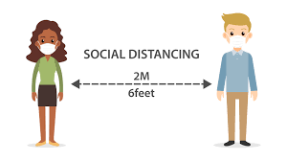
between users

Phase Two

Phase One measures + several weeks declining cases

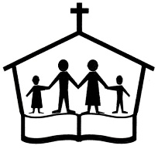
online worship < 50 in building, facemasks, social distancing, thorough cleaning

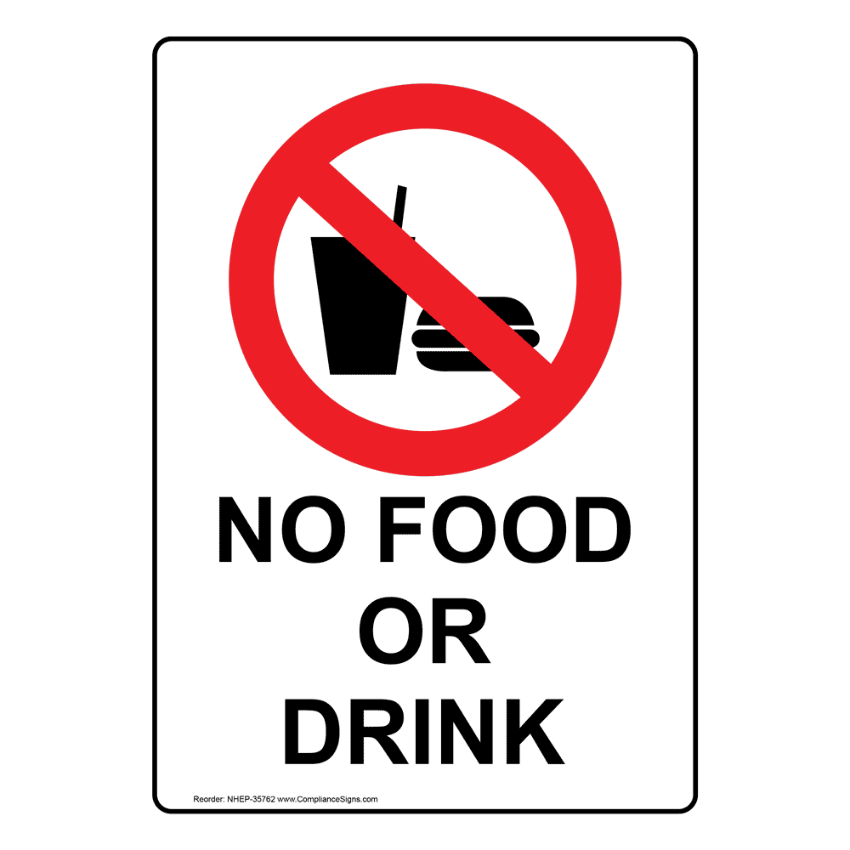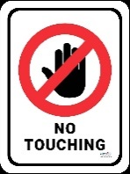
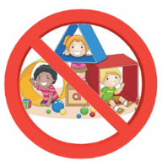
no bulletins/friendship Children stay with
pads/bibles/hymnals parents

Phase Three

Phase Two measures + several weeks declining cases

Online worship no limits on attendance
but limit crowding,
facemasks still recommended,
social distancing encouraged
watch public health guides for singing and eating (communion)
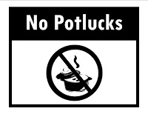
no bulletins/friendship pads/bibles/hymnals

